Press Release
www.ibs.re.kr

Embargoed until 14:00 U.S. Eastern Time Wednesday, 23 June 2021
Publication Information
- Paper Title: East Antarctic cooling induced by decadal changes in Madden-Julian oscillation during austral summer
- Journal, Publication Date: Science Advances; 23 June 2021
- Authors: Pang-Chi Hsu, Zhen Fu, Hiroyuki Murakami, June-Yi Lee, Changhyun Yoo, Nathaniel C. Johnson, Chueh-Hsin Chang, Yu Liu
- DOI: 10.1126/sciadv.abf9903
- Contact Regarding this Press Release: June-Yi Lee, Institute for Basic Science Center for Climate Physics, juneyi@pusan.ac.kr (+82-51-510-2217), Pang-Chi Hsu, pangchi.hsu@gmail.com
East Antarctic summer cooling trends caused by tropical rainfall clusters

A new study identifies key linkages between rainfall occurring in the tropics and climate trends in Antarctica

Our planet is warming due to anthropogenic greenhouse gas emissions; but the warming differs from region to region, and it can also vary seasonally. Over the last four decades scientists have observed a persistent austral summer cooling on the eastern side of Antarctica. This puzzling feature has received world-wide attention, because it is not far away from one of the well-known global warming hotspots – the Antarctic Peninsula.

A new study published in the journal Science Advances by a team of scientists from the IBS Center for Climate Physics at Pusan National University in South Korea, Nanjing University of Information Science and Technology, NOAA Geophysical Fluid Dynamics Laboratory, University Corporation for Atmospheric Research, Ewha Womans University, and National Taiwan University, uncovers a new mechanism that can explain the regional warming/cooling patchwork over Antarctica. At the heart of the mechanism are clusters of rainfall events in the western tropical Pacific, which release massive amounts of heat into the atmosphere by condensation of water vapor. Warm air rises over the organized rainfall clusters and sinks farther away. This pressure difference creates winds which are further influenced by the effect of earth’s rotation. The interplay of these factors generates a large-scale atmospheric pressure wave which travels from west to east along the equator with a speed of about several hundred kilometers per day and which drags along with it the initial rainfall clusters. This propagating atmospheric wave is known as the Madden-Julian Oscillation (MJO), named after Roland Madden and Paul Julian, who discovered this phenomenon in 1971. The characteristic atmospheric pressure, convection and wind anomalies, which fluctuate on timescales of 20-70 days, can extend into the extratropics, reaching even Antarctica.

The international research team arrived at their conclusions by analyzing observational datasets and specially designed supercomputer climate model simulations. “Our analysis provides clear evidence that tropical weather systems associated with the Madden-Julian Oscillation can directly impact surface temperatures over East Antarctica.” says Prof. Pang-Chi Hsu from Nanjing University of Information Science and Technology, who co-led the study.

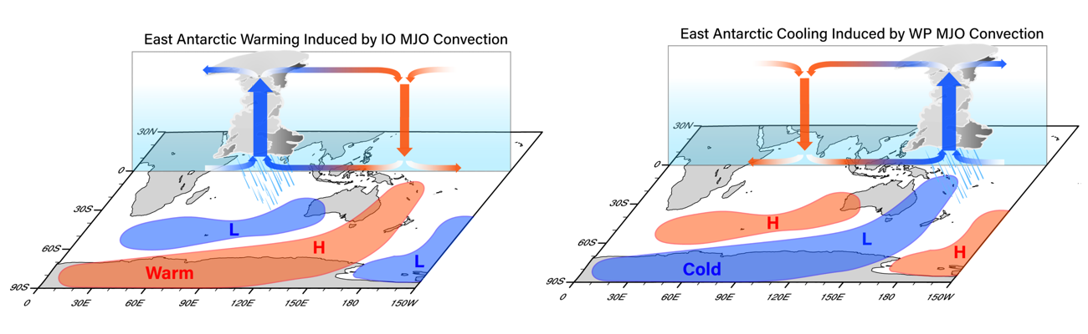
Changes in East Antarctic temperature due to MJO rainfall clusters. (Left) East Antarctic warming associated with an anomalous high pressure (H) excited by the MJO rainfall events in the Indian Ocean. (Right) East Antarctic cooling associated with an anomalous low pressure (L) caused by the MJO rainfall events in the western tropical Pacific. The blue (red) line indicates anomalous atmospheric low (high) pressure at sea level. (Image Credit: Zhen Fu)

More specifically, as the MJO rainfall clusters move into the western Pacific towards the location of the Solomon Islands, the corresponding global atmospheric wave tends to cool East Antarctica three to eleven days later (Image, right panel). In contrast, when the MJO-related rainfall occurs in the Indian Ocean, East Antarctic shows a pronounced warming (Image, left panel).

“During recent decades, MJO rainfall and pressure changes preferably occurred over the western tropical Pacific but decreased over the Indian Ocean. This situation has favored cooling of East Antarctica during austral summer.”, says Prof. June-Yi Lee from the IBS Center for Climate Physics and Pusan National University, and co-leader of the study.

The research team estimated that up to 20% to 40% of the observed summer cooling trend in East Antarctica from 1979 to 2014 can be attributed to the long-term changes in the character and longitudinal core location of the MJO. Other contributing factors include the ozone hole and the Interdecadal Pacific Oscillation – a slowly varying weaker companion of the El Niño-Southern Oscillation. The new Science Advances study highlights that climate change even in remote regions such as Antarctica, can be linked to processes that happen nearly 10,000 km away.

Notes for editors
- References
Pang-Chi Hsu, Zhen Fu, Hiroyuki Murakami, June-Yi Lee, Changhyun Yoo, Nathaniel C. Johnson, Chueh-Hsin Chang, Yu Liu, East Antarctic cooling induced by decadal changes in Madden-Julian oscillation during austral summer. Science Advances, 7, eabf9903 (2021) DOI: 10.1126/sciadv.abf9903

- Media Contact
For further information or to request media assistance, please contact: U-Jeong Seo, IBS Center for Climate Physics, Pusan National University (+82-51-510-7328, u_jeongs@pusan.ac.kr) or William I. Suh at the IBS Communications Team (willisuh@ibs.re.kr).

- About the Institute for Basic Science (IBS)
IBS was founded in 2011 by the government of the Republic of Korea with the sole purpose of driving forward the development of basic science in South Korea. IBS has 31 research centers as of March 2021.

- About ICCP
The IBS Center for Climate Physics (ICCP) seeks to expand the frontiers of earth system science by conducting cutting edge research into climate dynamics and utilizing high-performance computer simulations, with the goal of improving decadal Earth system forecasts and long-term projections. See more on http://ibsclimate.org

